BEDOUET Thomas

MARCAIS Paul

POLSTER Thomas

FPGA Project: communication between NI myRIO-1900 and LSM303AGR

with I2C protocol

We want to receive a byte (8 bits) from one of the microchip on LSM303AGR either the accelerometer or the magnetometer. Each data of those sensors is written on two bytes for a precision of 16 bits. Therefore, we would need to concatenate the two bytes to get the complete data.

The LSM303AGR datasheet gives us the following method: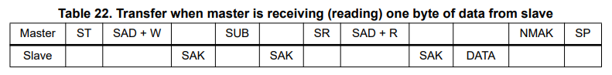

It describes the datas written on the SDA line by the master (NI myRIO-1900) or the slave (LSM303AGR).

It starts with the start condition: SDA = 0 when SLC = 1

Then SAD + W designate the address of the ship (accelerometer or magnetometer) with a 0 at the end to write.

In our labview project we use the write address of the accelerometer.

This is followed by an acknowledge bit from the slave. To allow the slave to write on the SDA line we first disable the output of the master, then, read the value on the SDA line.

Next we enter the register address of the data we seek, we find them here in the datasheet:

In our labview example we chose the most significant value of the acceleration following x (OUT_X_H_A).

Once again, we give back the right to write on the SDA to the slave and read the acknowledge bit.

After that we completed an entire writing protocol, so we need to re write the start condition.

Then we send to the slave the same device address but with a 1 at the end to read the data stored at the register address we just wrote.

And again we read the acknowledge bit.

Then we can finally read the byte of data we wanted.

At the end we send a master acknowledge bit to the slave and end with a stop condition : SDA = 0 & SCL = 0.

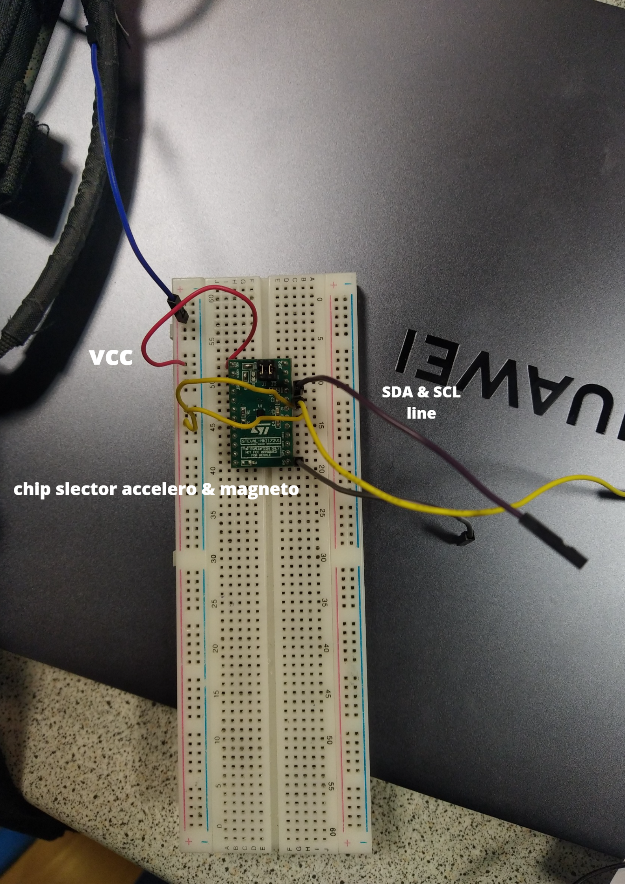

This is how we wire the chip, note that we set the two chip selectors on Vcc to ensure the selected protocol of communication is I2C and not SPI.